# Vacant Parking Slots Detection

A Graduate File Paper

Present to

Dr. Terry Griffin

CMPS 6901

Department of Computer Science

Midwestern State University

By

Kotiyala, Surekha

Grad File Paper

2014-2015

**Abstract**

Most students want to know where they can park when they arrive to campus. By creating a location-based service that provides a real-time state of an existing parking lot, we can assist students in making quick decisions on where they should attempt to park. This paper describes a system to detect vacant parking slots using common image-processing techniques. These techniques include: edge detection, corner detection, color detection as well as object detection and can be applied to an image (for example, a security camera) in real-time. In addition to identifying empty parking spaces, this system could be used to record parking space utilization and help make recommendations for parking improvements.

**1. Introduction**

Everyone tries to reach to the university on time or just before time for class. However, everyone doesn't get the nearest parking space to park their vehicles, which creates a problem for parking the vehicle on time and rushing to the classroom for the lecture. In this paper, identifying the empty parking spaces with various techniques and terminology are made.

**1.1 Purpose**

Most students want to know where they can park when they arrive in campus. This paper describes a system to detect vacant parking spaces using common image processing techniques. The various techniques are used, such as edge detection, corner detection, color detection, and object detection, and these are applied to an image by using a security camera in real-time.

**1.2 Motivation**

Availability of parking spaces is elusive especially at common class times in the university. Here is the problem which I faced when I ran out of time and did not find the parking space easily, which makes me turn my vehicle round and round in the parking area. For this, a system is developed for finding the location for parking a vehicle easily and using location-based services with image processing.

**1.3 Overview**

This paper is organized as follows: Section 2 describes various terminologies, how are they implemented for identifying the slots. Section 3 describes different problems from the case studies. Section 4 describes about the working process of identifying the available spaces in the parking slot. Section 5 describes future work for this paper. Finally, Section 6 gives the conclusion of the paper.

**2. Terminology and its implementation/ case studies**

Various terminologies have been used for detecting the parking slots. Every terms defined a different way of processing and finding the slots. The different terms are listed as follows:

**2.1 Image Filtering:**

Image Filtering mainly works on two-dimensional digital images. It is used for removing the unwanted part from the image and produces a new digital image from the existing image. There are various types of filtering techniques used for identifying parking slots. Different filters used for this system are explained as follows:

**2.1.1 Edge Detection:**

Edge Detection is detecting the sharp points from an image based on brightness for capturing the important changes in the image. The detection works with a set of mathematical operations and methods and identifies the sharp changes and discontinuities in surface orientation. There are different methods of performing an edge detection like, gradient method and Laplacian method.

Gradient method only detects the sharp points of an image, which works only in first order derivations for finding the edges, whereas Laplacian method works in second derivation and produces better filtering than a gradient method which, is used in this paper. Firstly, the noise in the image is removed by using filters. Then, an enhanced image is formed by using threshold operations.

For example, for identifying the edges of a given parking slot, all the sharp points in the image are identified, and this is a basic step for identifying the slot. The following is one of my experiment’s that is shown below:

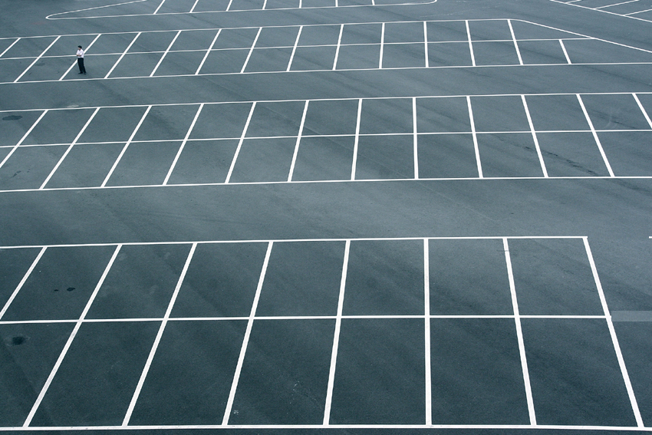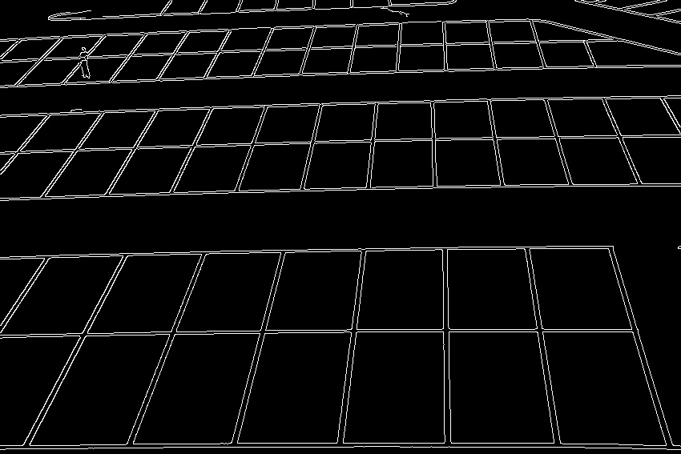

Fig. 1: actual Image and edge detection on the actual image.

**2.1.2 Object Detection:**

Object detection detects the instances of semantic objects from an image. When an object is detected, it displays in a completely filled-in form. An example below shows for identifying the object present in the image which is completely in filled-in form, you can see a man standing in the actual image is completely filled-in in the object detected image, which is as follows.

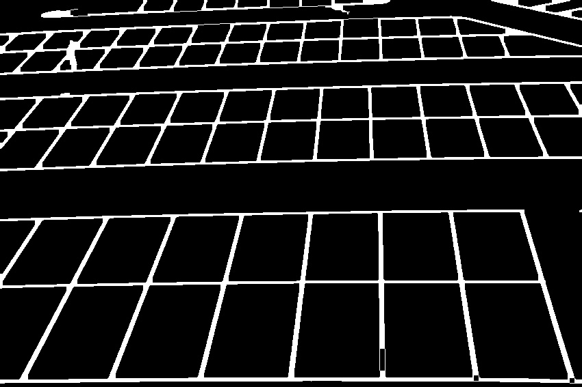

Fig. 2: actual Image and object detection on an actual image.

The drawbacks of this experiment were it detects the lines as also object.

**2.1.3 Corner Detection:**

The corners are identified by regions in an image. An image has different regions with large variations in intensity. It is basically for finding different intensities for displacement of all directions. Here is an example with which I have experimented for finding all the corners in the image by using Corner Harris Detection.

 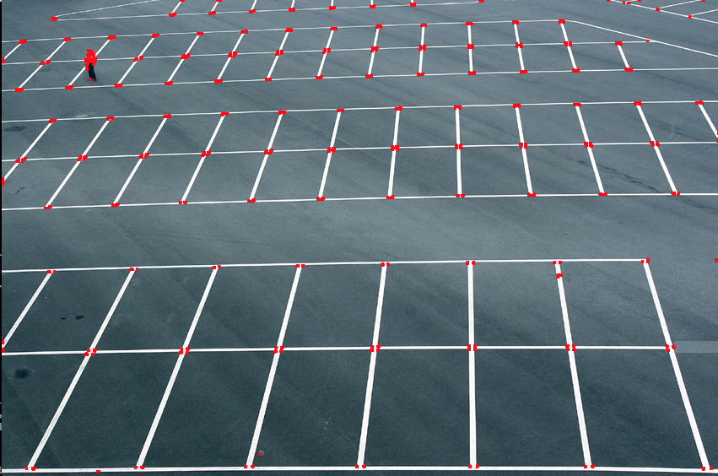

Fig. 3: actual Image and corner detection on an actual image.

**2.1.4 Line Detection:**

The straight lines are detected from a given image as an input. These straight lines can be horizontal or vertical without any curves. Hough Line Transformation is used for detecting the line in a given image. The number of lines obtained in the output image may vary because this depends on the threshold value in the code. This threshold value just works for filtering the image more sharply.

An experiment example is given below:

 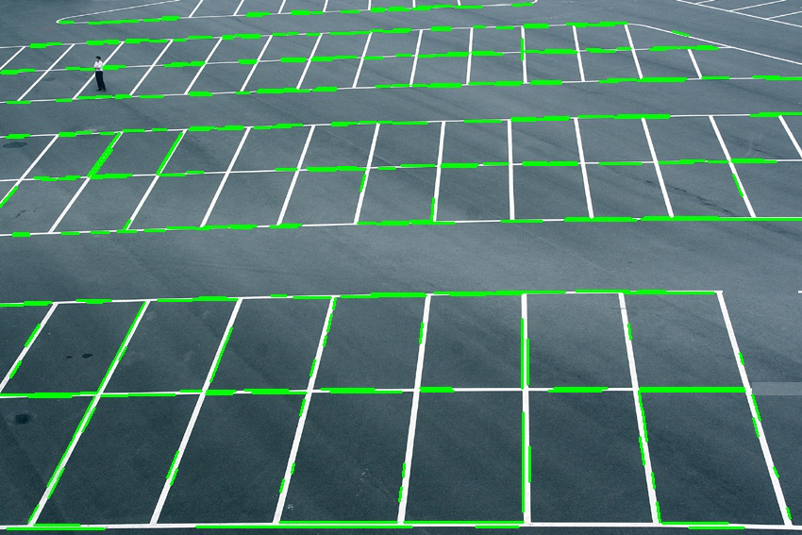

Fig. 4: actual Image and Line detection on an actual image.

The drawback of this experiment is some parts of lines are missing, which are unable to be fixed even if the threshold value is changed.

The combination of line detection and corner detection.

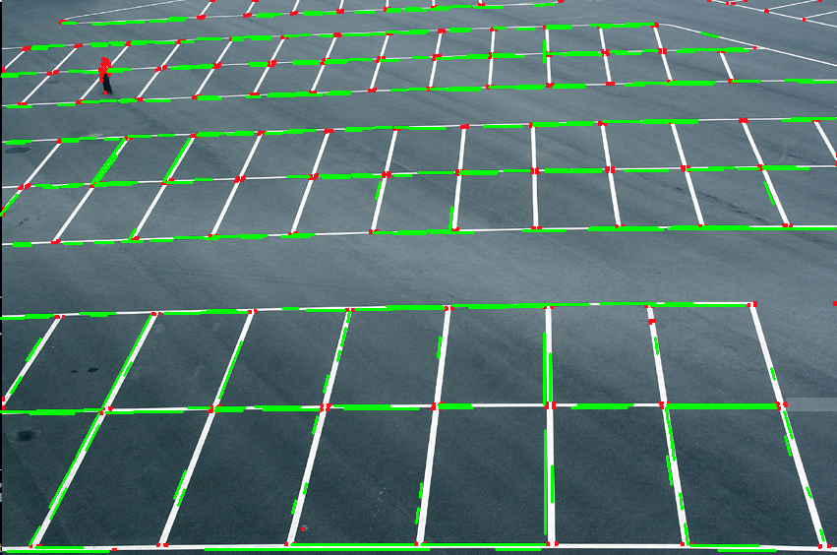

Fig. 5: Combination of line detection and corner detection.

**2.1.5 Color Detection:**

An image color is classified in Red, Green, and Blue. Every small image has a couple of pixels which have some set of color values that are categorized into red, green and blue. The color of each image is identified with its pixels and range of the color, for example red, green and blue have a range of 0-255. They are detected within their range, and the particular color is identified and displayed, and the rest of the colors are displayed as black.

 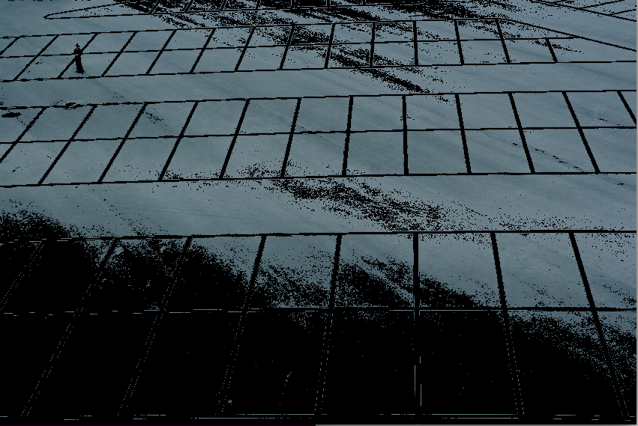

Fig. 6: Actual Image and color detection on an actual image on which gray color is identified.

**3. Problems**

There are problems for easy and automatic identification of a parking slot, and it is very difficult when it is applied to real-time robust parking spaces. The identification algorithm is possible to build, but they cannot obtain 100 percent correct results. As the drawbacks are possible for real-time images like in object detection the parking slot lines are also considered as objects, which are represented in filled-in form, and in line detection some lines are missing where it is difficult to identify whether it is an empty parking slot or an occupied parking slot.

**4. Working**

A real-time robust parking slot or space is identified by identifying the available spaces in the parking area. So, for identifying the spaces availability and finding the empty slots from the parking area by color identification provides a better results. There are few steps to identify the parking slots, which are as follows:

**4.1 Physically identifying the slots:**

Firstly, an empty parking slot is taken, and all the four corner of each slot are noted. That is, if a particular slot is considered from a parking area, the four coordinate points are noted by using pixlr editor tool in the form of [(x0,y0), (x1,y1), (x2,y2), (x3,y3)] which represents (x0,y0) for left top of the slot, (x1,y1) for right top of the slot, (x2,y2) for right down of the slot and (x3,y3) for left down of the slot. This is marked for all slots present in the parking area. These coordinates are used for traversing for each slot in parking space. These co-ordinates are represented in lists. The main file consists is co-ordinates of each parking slot in the parking space.

When the file is executed all the slots are detected in the output file. Though, it is used only at the initial stages for checking whether the particular slots are identified properly or not. For identification of detection of the slots, a green color border is obtained on top of the slots, which makes a clear understanding that slots are identified as shown below.

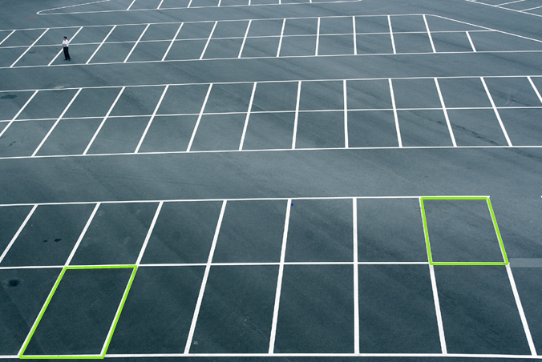

Fig. 7: Identifying the slots and marked the identified slots with a green border.

**4.2 Identifying the color:**

Once the slots are identified, next comes checking whether the slot is empty or occupied. For this, identification of the color plays an important role. Since, if there is some vehicle occupied in particular slots, a general identification can be made by colors. For example, if a red car in a slot is seen from a far place, everyone can say, “A red car is already occupied in that slot. Right!!!” So identifying through colors not only makes it easy to understand in real time, but it also helps in working easily for building a code with understanding.

From my experiment, I have noticed each slot has different color ranges in Red, Green and Blue (RGB) values. This is because every picture has a different amount of pixels. So, every pixel has a different color range. For example, consider one particular slot, and you can see the color variations for each pixel in that slot. The slot is in different color ranges of gray, and the color is calculated for each pixel differently and have different RGB values according to the pixels in box, which is as follows:

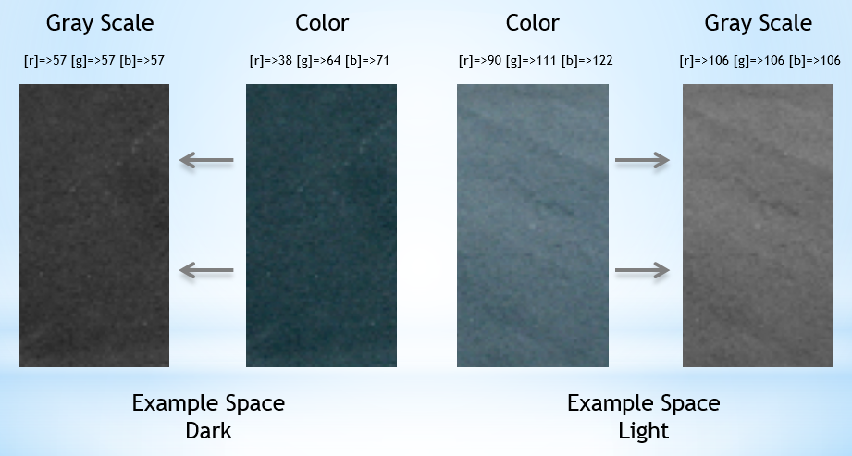

Fig. 8: Color variations for each pixel.

Further, from calculating for each slot, the color has varied. Since some slots might be in the shaded area while some are in a very bright area due to the sun reflection, the color identification for each slot has different color variations. For each slot the color is calculated, by calculating with each pixel by traversing from one co-ordinate axis to another within the four co-ordinate which is formed as a polygon. The actual image color has RGB values, but again it is calculated for each slot in the parking space to finding the average color.

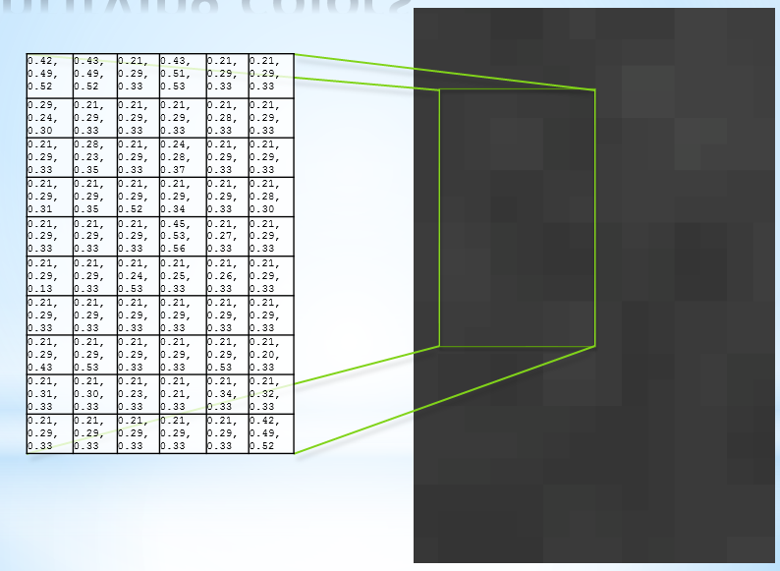

Fig. 9: Color variations at different slots.

**4.3 Threshold Value:**

When the color variations are seized while calculating the average color for each slot, all the gray slots are categorized to Threshold value. These Threshold values are identified by their ranges of RGB values and identification can be made whether that slot is empty or filled.

When a slot is considered, if the Threshold value is almost equal to the Average color of the slot then it is defined as an empty slot. For example, if an average color of a slot is 68, 66, 69 and Threshold value is 69, then it is accepted as an empty slot. It is accepted for two values before and after the range for a given Threshold.

For a particular slot, when the slot is empty, the RGB values are recorded. Now, consider the same slot is occupied with a car. The color difference is again recorded and tested, whether a slot is empty or not. In some cases, the car color might be very light, for example a gray car. The average color is calculated and checked with the Threshold values, and it is decided whether the slot is empty or filled with a vehicle. Likewise, this is checked with dark cars like black and the same procedure is repeated. Here is an example which helps in understanding clearly.

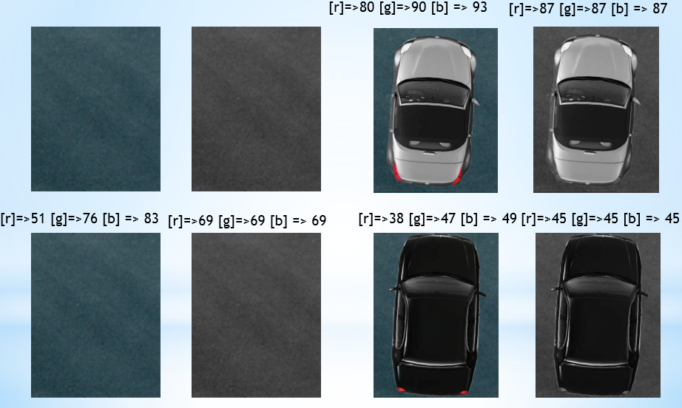

Fig. 10: Color variations with different cars.

**4.4 Detection of empty slot:**

Finally, the number of empty slots in a parking space is displayed. This is displayed, with the slot area. These empty slot are calculated, while checking with the threshold range. When the threshold range is almost equal to the color of the slot, then it is incremented by one for every empty slot. And the empty slot number remains same when, a particular slot is not empty in the parking space.

**5. Future work**

This system can be designed as an application for mobiles in different platforms where it will be more useful for students and faculty for tracking the slots when they are available by getting the updates in the mobile phone. Even a drone can be used in parking slot areas which can display on a big screen, for showing the available parking slots, which can make a dynamic application.

**6. Conclusion**

This system works only for static images. The concept of identifying the slots saves a lot of time for both students and faculty while they are running out of time. It is more effective and easy to locate the availability of empty parking slots. It will be extensively used when it is developed as a mobile application.

**7. References**

1. Canny, J., A computational approach to edge detection, proceeding IEEE transactions on pattern analysis and machine intelligence, vol. Pami-8, no.6, November 1986.
2. Comaniciu, D., Meer, P., Robust Analysis of feature spaces: Color Image Segmentation, Department of Electrical and Computer Engineering Rutgers University, Piscataway, NJ 08855, USA.
3. Lindberg, T., Feature detection with automatic scale selection, Computational vision and active perception laboratory (CVAP), Department of numerical analysis and computing science, KTH (royal institute of technology), S-100 44 Stockholm, Sweden, received February 1, 1994; revised june 1, 1996; accepted july 30, 1998.
4. Manzanera, A., Local jet feature space framework for image processing and representation, Laboratoire d’Electronique et Informatique ENSTA-ParisTech, Paris, France.
5. Papanikolopoulos, N.P., martin, R.F.K., Masoud, O., Gupte, S., Detection and classification of vehicles, IEEE transactions on intelligent transportation systems, vol.3, no.1, march 2002.
6. Torres, F.A.J., Automatic parking lot occupancy computation using motion tracking, the college of engineering and computer science in partial fulfillment of the requirements for the degree of master of science, Florida Atlantic university, Boca Raton, Florida, august 2013.
7. Yusnita, R., Norbaya, F., Basharuddin, N., Intelligent Parking Space Detection System Based on Image Processing, International Journal of Innovation, Management and Technology, Vol. 3, No. 3, June 2012.
8. Zabawi, N H B., Sunardi., Ghazali, K H., Parking lot detection using image processing method,ICLTEEE 2013.